9th Annual Living With and Beyond Cancer Conference
Saturday, March 28
Central United Methodist Church, Albuquerque

Implementing Dream Therapy Support Groups as Part of an Integrative Medicine Approach to Cancer
SHARI TARBET, PHD

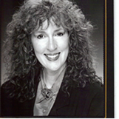

One of four choices of Breakout Sessions
Shari received an MA/PhD in Mythological Studies and Depth Psychology from Pacifica Graduate Institute. She has worked with Tullulah Lyon, M.Ed., of the International Association for the Study of Dreams, on the Dream and Healthcare project and the Healing Power of Dreams website. She has 30 years of experience in public education and 20 years of experience in dream work.

Conference is FREE, Registration is required. Please register online at cancersupportnow.org OR call and leave a message for Valerie with you name & number 505-265-9000

