CONFERENCE REGISTRATION NOW OPEN!!
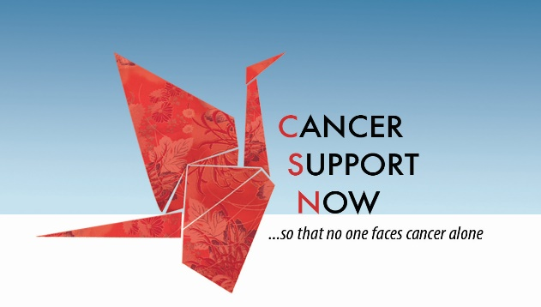
Cancer Support Now
9th Annual Living with and Beyond Cancer Conference
Saturday, March 28 8:30am-2:45pm
Central United Methodist Church 201 University Blvd NE, ABQ

Last Name:

First Name:

Address:

Email:

Phone:

FREE Conference, Registration Required by March 15, includes, breakfast, lunch, all materials, 2 Speakers, and a Breakout session

Opening Speaker: Mission Nutrition – Ernestine Trujillo, RD

Breakout Sessions 11:15am to 12:30pm – Please Choose One
- Healthcare for Transgender and Non-Binary People – Adrian Lawyer
- Implementing Dream Therapy Support Groups as part of an Integrated Medicine Approach to Cancer– Dr. Shari Tarbet
- Coping With Long-Term Side Effects: Dental and Hearing - Dr. Steve Wagner & Dr. Therese Sankovits
- Acupuncture During and After Cancer Treatment – Dr. Neil Sirwinski

Luncheon presentation: Communicating with Your Medical Providers: Improv with Jason Pfifer & Irene Loy

More information about each speaker/topic will be emailed and posted on the website.

Registration Required:
This form is available to Register online www.cancersupportnow.org, OR download the registration form, complete it, and mail to us at Cancer Support Now, Inc., PO Box 37338, Albuquerque, NM 87176 by March 15 OR call and leave a message for Valerie with you name & number 505-265-9000

SPONSORED IN PART BY:

For anyone who needs lodging the night before:
We have arranged a deal with LaQuinta Inn Midtown, Menaul near University, set behind the Village Inn. Queen or King room will be $99.00. King room has one bed, queen room has 2 beds.
http://www.laquintaalbuquerquemidtown.com/en/home.html
Just call the hotel direct at 505-761-5600, and ask for Cancer Support Now rate of $99.00 for March 27.

